Configuring WANs and NAT - Worksheet

Before you begin this project, it is important that you review some basic concepts. As you work through this project, keep these in mind:
- To preserve IPv4 addresses, almost everyone uses private IPv4 addresses behind their routers. These network ranges are 10.0.0.0 – 10.255.255.255, 172.16.0.0 – 172.31.255.255, and 192.168.0.0 – 192.168.255.255. These addresses ARE NOT routable on public networks. To get access to the public internet, some form of NAT is necessary to link a private address to a public address.
- Most residential users take advantage of Dynamic NAT/PAT. This allows multiple users to share a single public IP address.
- Most companies offering public facing services will use Static NAT. This is a 1-to-1 mapping of a private to a public IP address. This is more expensive than NAT/PAT because the company must procure multiple public IP addresses.
- Dynamic NAT is not used as often as NAT/PAT. In pure Dynamic NAT, many private users share multiple public IP addresses. As this project will demonstrate, this can cause some confusion. When coupled with the “overload” command, however, Dynamic NAT can provide load balancing and resiliency for users.
 | Points Possible | Points Awarded
- Open Configuring_WANs_and_NAT_Student_Project.pkt. Give the network some time to converge. Open any of the computers in Ogden. All computers on the 192.168.1.0 and 192.168.4.0 networks should receive DHCP addresses on the network. Attempt to ping FTP (192.168.5.4) and Ogden DNS. You should be successful. Open Provo Admin. It should be statically configured as 172.16.0.5. Attempt to ping Provo DNS (172.16.0.6). It should succeed. Open the Web Browser and attempt to access “www.ralph.com”. When successful, access “www.company.internal”. This should also succeed.
- Connect Ogden to Provo using the correct serial cable. When the interfaces are up, open the Ogden CLI and ping the Provo router (198.3.24.4). It should fail. Paste snip below. Troubleshoot by continuing to step 3.

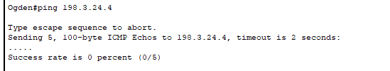 | 2
- Configure the WAN link between Provo and Ogden using PPP encapsulation. When completed, ping Provo from Ogden.
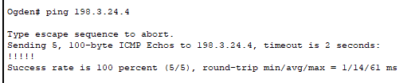 | 2
- Open W2 and attempt to ping Provo Admin (172.16.0.5). It will fail. Open the Provo CLI and try to ping one of the “W” workstations (192.168.1.4 should be one of them). It will fail. Let’s troubleshoot the failures. In a multi-router situation, routing is often the cause. Default routes have been configured on both routers which would let the ping succeed. Why does it fail? The next logical thing to examine firewalls. In this case, no PC firewalls have been configured so that isn’t causing the failure. Examine the “Show Running Configuration” on both routers. Is there something in the configuration that is blocking the ping attempt? The answer should be “Yes”, and it is intentional. Take a snip of the configuration section affecting the pings.
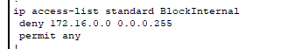  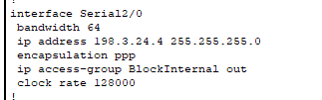 | 2
- Implement NAT/PAT on the 192.168.1.0 network on the Ogden router. Use the outgoing public address (198.3.24.3) as the translated address. Open a command prompt on W3. Run ipconfig. Note the IP address. Ping the Simulated Internet (198.168.5.2) is should succeed. Open the Web Browser and access “www.ralph.com”. It should succeed. Open a command prompt on the Simulated Internet. Ping the IP address of W3. It should succeed, BUT what does the reply show as the source of the reply? Open the Ogden CLI. Run the “show ip nat translations” command from Privileged Exec mode. What does it show about the “W3” workstation address? Paste the results below with the mappings highlighted.

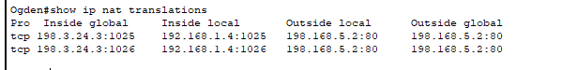 | 4
- Create Static Nat on FTP, Company Web Server, and Provo Admin. You’ll find the IP addresses to use in the Configuring WANs and NAT Assignment (in Canvas), in the “IP Assignments for the project” tables. Hint: look for “static” in the NAT type column. When complete, test your solution by opening W4 and pinging Provo Admin (198.3.24.10) and Company Web Server (198.3.24.5). Open the Web Browser and access “www.company.internal”. Paste the results below.

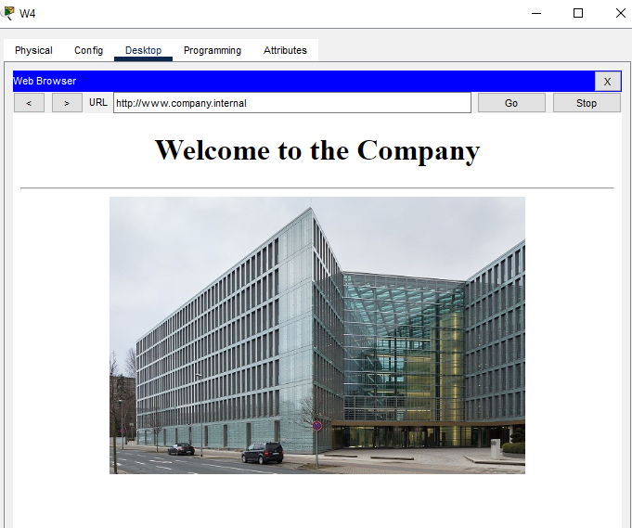 | 4
- Configure Dynamic NAT on the 192.168.4.0 network on the Ogden router. Please note that you have only been given 2 public IP addresses (198.3.24.8 and 198.3.24.9) to put in the ip nat pool. Open A1 and ping the Simulated Internet (198.168.5.2). It should succeed. Open A2 and do the same. It should also succeed. Open A3 and do the same. It should fail. Describe below why the ping failed.
The ping from A3 failed because the NAT pool only contains 2 public IP addresses (198.3.24.8 and 198.3.24.9). Since A1 and A2 are already using those addresses, and we are not using 'overload' (PAT), there is no public address available for A3 until one of the others is cleared. | 2
- Open the Ogden CLI. From Privileged Exec type “clear ip nat translation *”. Return to A3. Ping the Simulated Internet (198.168.5.2). It should succeed. Open the Web Browser and access “www.company.internal”. Paste the results below.
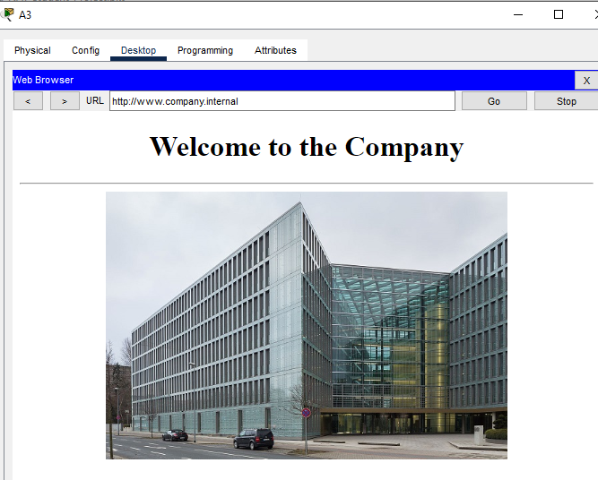 | 2
- Open Provo Admin. Open a command prompt. Type “ftp ftp.company.internal.” When prompted enter “cisco” for the username and “cisco” for the password. From the ftp prompt, type “get CompanyInfo.txt”. Close the command prompt and open the text editor. From the file menu (it simply says “File”) select open. Double click the CompanyInfo.txt file. When it opens, take a snip of the file and past below.
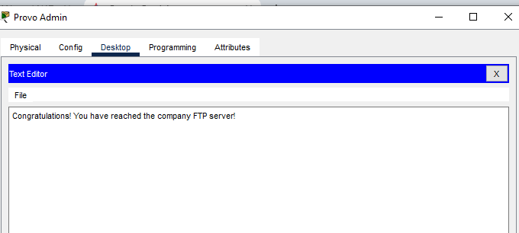 | 1
- Open the Ogden CLI. Type “show ip nat translations” from Privileged Exec. Take a snip of the translation from the FTP transaction and circle it. Paste the snip below.
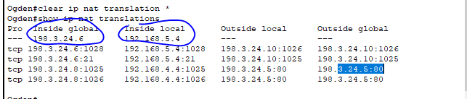 | 1
Total Points | 20

